Research Proposal: Multiplication Fact Fluency and Multiplication.com
Jacqueline Felix, Jacquelyn Montanez, Sarah Wales
California State University, San Bernardino

Multiplication Fact Fluency and Multiplication.com

Introduction
We have observed that it is common practice to utilize the games on Multiplication.com as a way to improve multiplication fact fluency. These games are sometimes used as an incentive to finish independent work and sometimes as a “sponge activity” to keep students occupied while the rest of the group finishes. Given this common practice, we question the effectiveness of using this website in this way. Our proposal is to study the effectiveness of using online games to build multiplication fluency, and specifically study the online game “Tug Team” on Multiplication.com to determine if it increases student multiplication performance and interest in learning multiplication facts. A review of literature on this topic has revealed mixed results. Several state that computer based games are effective at improving learning outcomes while others saw minimal to no improvement. Game characteristics seem to be a key element when determining the potential effectiveness of specific games. Our literature review led us to the conclusion that a collaborative game such as Tug Team will have the greatest chance of being effective. To determine whether or not this is true, we will utilize mixed methods to collect quantitative and qualitative data in the form of a pre and post assessment of multiplication fact fluency, along with pre and post interviews of the participants regarding their attitudes toward memorizing multiplication facts. The knowledge obtained from this study will benefit other educators, who want to implement games properly into their lesson plans, so their students learn the material presented to them via gameplay.
Literature Review

A search through the literature on the topic of computer math games found studies that compare the effectiveness of traditional paper and pencil based methods to the effectiveness of using computer games to supplement instruction. The articles we found had conflicting results. In the first article, “Does Math Achievement ‘h’APP’en’ When iPads and Game-based Learning are Incorporated Into Fifth-grade Mathematics Instruction?” one group was taught using only traditional methods, and the other group supplemented instruction with math apps on iPads for nine weeks. Pre and posttest scores revealed no significant difference in performance between the two groups (Carr, 2012). In the second study, “Differential Effects of Learning Games on Mathematics Proficiency,” the same basic format was used of using only paper and pencil for one group and comparing their pre and posttest scores to those of the group that used a math game app for nine weeks, but this study did find a positive effect on students’ math proficiency (Chang, Evans, Kim, Norton, & Samur, 2015). This suggests that not all computer based games are effective at enhancing traditional methods of instruction, but that there is potential for their use in the classroom. To further develop our understanding of this we must examine what makes certain games effective, and what makes them ineffective?
Further searching revealed more articles that found games to be ineffective at improving learning outcomes for students. “Table-based Math Assessment: What can we Learn From Math Apps?” presented a variety of math apps that assess different math skills, but asserted that many of the apps neglected to incorporate any multistep problem solving, although they were effective for assessing basic math skills (Cayton-Hodges, Feng, & Xingyu, 2015). This shortcoming in the area of multistep problem solving could explain why computer games fail to produce stronger outcomes for students in some studies, but does not apply to the question of whether the games on Multiplication.com are effective for improving math fact fluency, since fluency is a very basic skill. “Hey, I’m Learning This,” presents a general overview of the perceived positive and negative effects of gaming in the classroom, stating that gaming may promote a positive learning environment and motivation but that using the games as a reward may have a negative impact on learning (Bragg, 2006). This is of particular relevance to our topic since it is common practice to use Multiplication.com as a reward activity in the classroom. Bragg cites a study that found that children rush through their work to get to a game, resulting in poorer learning outcomes. These articles suggest that our study of students using Multiplication.com needs to be structured so that the games are not used as a reward activity, and that due to the simplicity of the skill being addressed, namely fact fluency, the games may be effective tools to support learning.
A few studies found this to be true, that multiplication fact fluency is indeed a skill that can be effectively supported and enhanced by computer games, but the authors of these studies had various explanations for why the apps studied were effective (De Witte, Haelermans, & Rogge, 2015; Musti-Rao, Lynch, & Plati, 2015; Rave & Golightly, 2014). These articles suggest that the technology be used systematically, including training on how to use the apps (De Witte, Haelermans, & Rogge, 2015; Musti-Rao, Lynch, & Plati, 2015). This indicates that computer games can be effective tools for supporting multiplication fact fluency specifically, but it is unclear whether or not the games that are being studied in these articles are similar to the any of the many games that are on Multiplication.com. To select a game that has a strong likelihood of being effective, we need to identify some of the attributes of effective computer games.
The first attribute appears to be that the game be fun so that students are motivated to play and excel at the game (Kebritchi, Hirumi, & Bai, 2010). Fun is at least in part determined by the method of gameplay, with collaborative and competitive games being the most motivating (Plass et al., 2013).
To take advantage of this effect, we narrowed the game selection to the multiplayer games on Multiplication.com, and found that Tug Team is both competitive and collaborative, so it may be an excellent game to focus on. Finally, the article, “Adaptivity in Educational Games: Including Player and Gameplay Characteristics,” stated that studies of computer gaming in education may fail to produce improved outcomes because of a lack of consideration for learner characteristics during gameplay (Vandewaetere, Cornillie, Clarebout, & Desmet, 2013). The authors propose a multilayer, player centered adaptivity model. Applying such a model to Multiplication.com is not within our power, but there is some adaptivity built into the website in that the teacher or students are able to select the specific multiplication fact families that will be targeted in the game.
Methodology
Research Questions
We will employ mixed methods research questions. The research questions are:
- Does the online game “Tug Team” on Multiplication.com increase multiplication performance among fifth grade students?
- Does the online game also increase student interest in learning multiplication facts?
Subjects
The participants of the study will consist of three groups. Each group will be made of approximately 30 fifth grade students. All participants will be from general education classes at the same elementary school.
Data Collection
Data collection will be done in the classroom before and after the three month period of students using Multiplication.com. The data will be collected in the form of assessments and student interviews.
Prior to students beginning Multiplication.com, they will complete a multiplication pre-assessment. The pre-assessment will be composed of 100 single digit multiplication problems for facts 1-10, in a five minute time limit. In addition to the multiplication assessment, students will be given a link to open-ended pre-interview questions via Google forms that are designed to elicit their views toward studying and understanding multiplication facts.
Once students have used Multiplication.com for a three month period, they will complete a multiplication post-assessment that is the same as the pre-assessment but with the problems in a different order. The post-assessment will be composed of 100 single digit multiplication problems for facts 1-10, in a five minute time limit. In addition to the multiplication assessment, students will be given a link to open-ended post-interview questions via Google forms that are designed to elicit their views toward the structure of “Tug Team” and their understanding of multiplication facts.
Data Analysis
The pre and post multiplication assessments will be graded by teachers using point value. Each question will be worth one point, with a total of 100 points. Once assessments have been graded, they will be entered into an excel spreadsheet. The spreadsheet will contain student names, teacher names, and scores for each assessment. The data will be used to look for trends among classes and specific students. Most importantly, student scores will show whether or not multiplication performance increased as a result of using the online game “Tug Team” from Multiplication.com.
The pre and post student interviews will be analyzed by teachers. Student responses to the open-ended questions will be exported to an excel spreadsheet. Both sets of data will be read carefully. A coding frame will be used to color code themes found in students’ responses. Student responses will help teachers know whether or not student interest in studying multiplication facts increased as a result of using the online game “Tug Team” on Multiplication.com.

References
Bragg, L. A. (2006). Hey, I’m learning this. Australian Primary Mathematics Classroom, 11(4),
4-7.

Carr, J. M. (2012). Does math achievement “h’APP’en” when iPads and game-based learning are
incorporated into fifth-grade mathematics instruction?. Journal of Information Technology Education: Research, 11, 269-286.

Cayton-Hodges, G. A., Feng, G., & Xingyu, P. (2015). Tablet-based math assessment: what can
we learn from math apps?. Journal of Educational Technology & Society, 18(2), 3-20.

Chang, M., Evans, M. A., Kim, S., Norton, A., & Samur, Y. (2015). Differential effects of
learning games on mathematics proficiency. Educational Media International, 52(1), 47-57.

De Witte, K., Haelermans, C., & Rogge, N. (2015). The effectiveness of a computer-assisted
math learning program. Journal of Computer Assisted Learning, 31(4), 314-329.

Kebritchi, M., Hirumi, A., & Bai, H. (2010). The effects of modern mathematics computer
games on mathematics achievement and class motivation. Computers & Education, 55(2), 427-443.

Musti-Rao, S., Lynch, T. L., & Plati, E. (2015). Training for fluency and generalization of math
facts using technology. Intervention in School & Clinic, 51(2), 112-117.

Plass, J. L., O’Keefe, P. A., Homer, B. D., Case, J., Hayward, E. O., Stein, M., & Perlin, K.
(2013). The impact of individual competitive, and collaborative mathematics game play on learning, performance, and motivation. Journal of Educational Psychology, 105(4), 1050-1066.

Rave, K., & Golightly, A. F. (2014). The effectiveness of the Rocket Math program for
improving basic multiplication fact fluency in fifth grade students: a case study.
Education, 134(4), 537-547.

Vandewaetere, M., Cornillie, F., Clarebout, G., & Desmet, P. (2013). Adaptivity in educational
games: including player and gameplay characteristics. International Journal of Higher Education, 2(2), 106-114.

Appendix A

The following questions will be utilized to collect qualitative data in the form of a pre and post interview.

Pre-interview Questions

- How do you feel about studying your multiplication facts?
- How do you currently study your multiplication facts?
- How often do you study your multiplication facts?
- How well do you feel like you know your multiplication facts from 1-5?
- How well do you feel like you know your multiplication facts from 6-10?

Post-interview Questions

- How do you feel about studying your multiplication facts?
- How well do you feel like you know your multiplication facts from 1-5?
- How well do you feel like you know your multiplication facts from 6-10?
- Did you enjoy playing “Tug Team” on Multiplication.com?
- What did you like about it?
- What did you like least about it?

Appendix B

The pre and post assessment of multiplication fact fluency provided below will allow us to measure quantitative data.

Pre-assessment
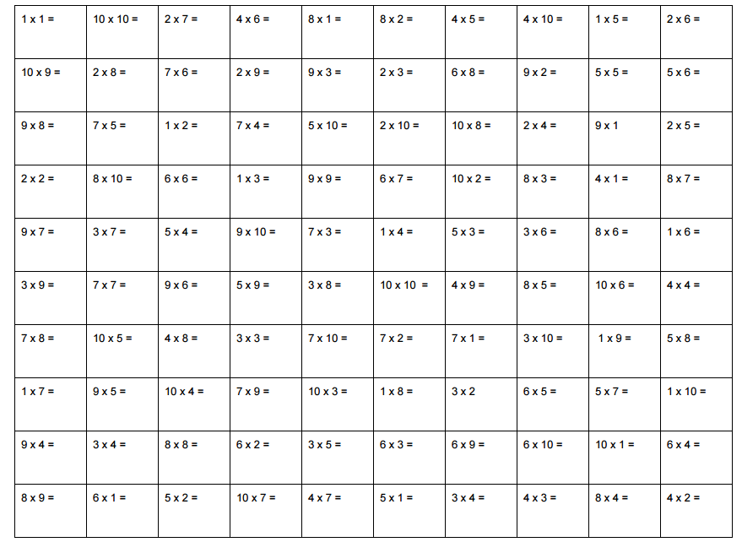

Post-assessment
